Creating and Running Angular Project
1.🛠️ To install angular globally (only once)
✅ Command:
npm show @angular/cli versions
npm install -g @angular/cli
ng --version
2. Create New Angular Application (ng new)
✅ Command:
ng new my-first-app
🔸 DRY RUN (--dry-run)
✅ Purpose:
To preview what will be created without actually generating any files.
🧠 For Freshers:
It’s like a trial run. Angular will tell you:
- What folders and files will be created.
- Without actually creating them.
✅ Command:
ng new my-first-app --dry-run
🔸 Skip Test Files (--skip-tests)
✅ Purpose:
To avoid generating .spec.ts (test) files. Makes the project cleaner for beginners or demo projects.
✅ Command:
ng new my-first-app --skip-tests
✅ Combined Command: for creating project with NO NgModule (Standalone structure)
ng new my-first-app --skip-tests

✅ Combined Command for creating project with NgModule (No Standalone structure)
ng new my-app2 --skip-tests --no-standalone

✅ Summary Table for Freshers
Option | Command | Purpose
--dry-run | ng new my-app --dry-run | Simulates file generation without creating anything
--skip-tests | ng new my-app --skip-tests | Avoids creating .spec.ts test files
Combine Both | ng new my-app --skip-tests --dry-run
With Module | --no-standalone

📁 Directory Structure (--skip-tests applied)
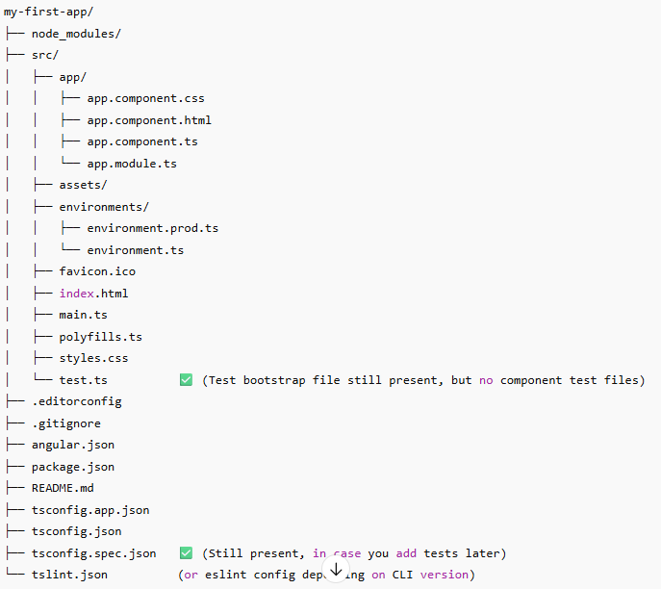

🧠 Tip for Freshers:
Think of --skip-tests like saying:
“Hey Angular, I don't want component-specific test files right now, but keep test support ready if I change my mind later.”
3.🚀 CLI Commands to Run Angular Project
Command | Purpose
ng serve | Run the app locally
Ctrl + C | Stop the server
ng build | Build the app (not needed for ng serve)
ng serve --open | Runs app and opens browser automatically

4.🚀 Angular Project Bootstrapping
✅ What is Bootstrapping?
Bootstrapping in Angular means:
🔧 Starting the Angular app by loading the root module (AppModule) and the root component (AppComponent)
🧠 Step-by-Step Bootstrapping Flow
- Index.html->provides placeholder
- main.ts ->starts Angular (Bootstrapping function → bootstrapApplication)
- AppComponent->fills the placeholder
index.html
↓
<app-root>
↓
main.ts (bootstrapApplication)
↓
AppComponent
↓
Rendered UI (App.html)

5.🛠️ Angular CLI Commands Cheat Sheet (with Descriptions)
📁 Project Creation & Setup
Command | Description
ng new <project-name> | Creates a new Angular project
ng new <project-name> --skip-tests | Creates a new project without test files
ng new <project-name> --dry-run | Simulates project creation without writing files
ng add <package-name> | Adds a library (e.g. ng add @angular/material)

🚀 Serve & Build
Command | Description
ng serve | Runs development server (localhost:4200)
ng serve --port <number> | Run on a custom port (e.g. 4300)
ng serve –open | Automatically opens browser
ng build | Compiles the app into /dist folder
ng build –prod | Builds optimized production version

🧱 Generate Code (Scaffolding)
Command | Description
ng generate component <name> or ng g c <name> | Creates a new component
ng generate module <name> or ng g m <name> | Creates a new module
ng generate service <name> or ng g s <name> | Creates a service
ng generate class <name> | Creates a TypeScript class
ng generate directive <name> | Creates a directive
ng generate pipe <name> | Creates a custom pipe
ng generate guard <name> | Creates a route guard
ng generate interface <name> | Creates a TypeScript interface
ng generate enum <name> | Creates an enum
ng generate application <name> | Adds a new app to a workspace

📌 Tip for Freshers
Symbol | Meaning
ng | Angular CLI prefix
g | Short for generate
c, m, s | Short for component, module, service, etc.

✅ Why Standalone Components Are Now the Best Practice
Angular's core team officially recommends Standalone APIs (components, directives, pipes without NgModules) for:

Benefit | Description
✅ Simpler Code | Less boilerplate (NgModule declarations, imports, etc.)
🚀 Better Tree-Shaking | Smaller bundle size because only used components are included
🧠 Easier Learning Curve | No need to learn the dual system of Modules and Components
🔄 Lazy Loading is Easier | Lazy load components directly via routes
🔧 Modernized Architecture | Aligns better with modern front-end patterns like React/Vue

